CHAPTER 1
INTRODUCTION

Many issues have been related to the global warming. One of the effects of global warming is the dryness of soil in plantation. Increased in temperature will caused the soil to become very dry and not suitable for agricultural activities. As a result, there will be plants' malnutrition, as the nutrients came from the microbial activities in the soil. Microbial activities will slowly decreasing with increasing temperature [1].
Thus, soil moisture is important for forecasting both temperature and precipitation. As the temperature rises the evaporation rate of soil moisture increases. The increased soil moisture evaporation helps cool the ground [2]. On the other hand, soil moisture is a crucial variable in environment and climate systems. It has great impacts on agricultural and hydrological processes, and acts as a key role in agricultural [3].
Furthermore, people in urban area tend to grow plants in pots on their balconies but due to their busy schedule they do not have time to take care of their garden [4][5]. Because of that, people tend to water their plant in untimely manner. Sometimes, people tend to water the plants more than they require. Too little water as well as too much water will be harmful for the plants. If the soil is too dry, plants are unable to develop and become susceptible to damage from pests. On the other hand, if the soil too wet, the plants are prone to get rots and other diseases [6] [7]. Besides, plants need specific amount of water to grow, reproduce and photosynthesis.
Thus, this proposed system will reduce time and energy of the user in maintaining their farm. This system will mainly be monitoring the water intake of the plants by measuring the water content in soil using the soil moisture sensor. The moisture level obtained from the sensor is matched with the value that has been set in the Arduino. If the moisture content is low, the Arduino will give a command to water the plant and vice versa. The water will stop until the sensor reading reached the specified programmable value for the farm soil. Therefore, this technology helps to report directly to the user in an easy way to understand format through their cellular phone.

CHAPTER 2
RELATED WORK

Other microcontroller board such as MSP430F149 core circuit and others complex component which more complex than our system compared to this system that been using Arduino microcontroller [8].
Some of the systems are connected to internet which not reliable and feasible for farm that are not internet ready. [9], the system is connected and control via internet. The sensor readings that are obtained by the microcontroller are displayed over the internet and user can only monitor and send instruction via internet.
Wireless sensor has been used in [10], to detect the soil moisture. But, due to instability and expandability, the system has to develop two tiers working procedure which is data stream processing and the other is analyzing sensor data. Data stream processing will convert sensor data to DBMS format. While analyzing sensor data will predicts future soil moisture data based on the amount of water needed for irrigation based on predictive value and send control command to control the watering system. Thus, this tier makes this system become more complex to design.
Aravind Anil et.al [11] shows a system that used ATmega 328. Besides, this whole unit of system is powered by non-conventional electricity which was solar electricity. The purposed of using solar energy was because, less maintenance, fuel free and pollution free. This system also used collection from direct water rain drops as watering system instead of provided tanks. This is not feasible to be applied in the country that received least amount of rain drops. It is why watering system been implemented, to watering the plants accordingly to their needs.

CHAPTER 3
SYSTEM OVERVIEW
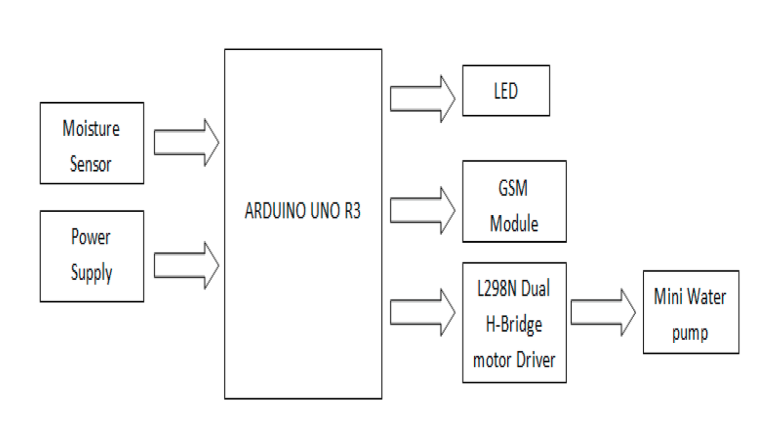
Figure 3.1: System Overview

This project builds a prototype that will detect the moisture level in the soil through sensor. It performs the controlling action using Short Message Services of cell phones. It has been implemented based on observation that many people loves to do gardening but find it difficult to maintain their garden due to their busy schedule. Moisture sensor signifies a detection and warning level. Once moisture sensor triggered the moisture level in soil, an output signal will be relayed to Arduino which serves as a switch that triggers the connected GSM modem to send a simple text message to the server that the soil is dry. Then, the water pump/motor started working after the user replying back the SMS whether 'ON' (water the plant) or do not do anything as specified by the coding. The water pump will potted the plant until the sensor reading reached below than 500 (programmable) reading. The process repeats as the moisture level triggers value more than 500.

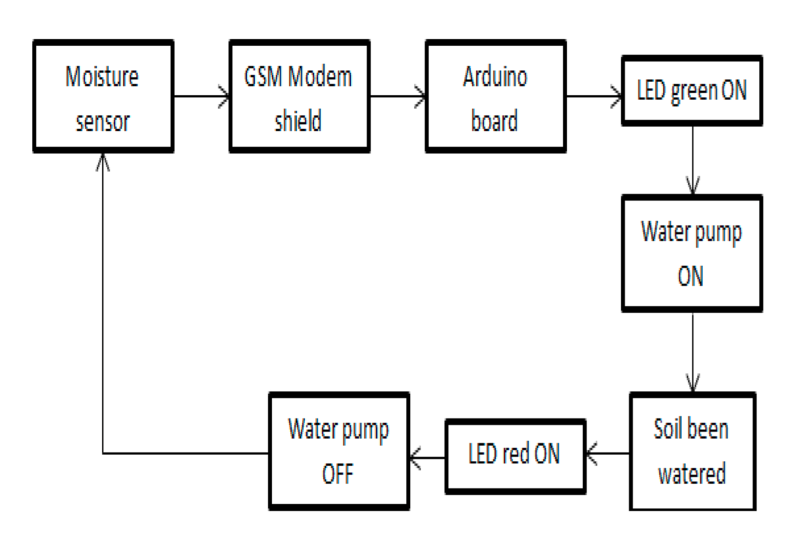
Figure 3.2: Overall System Structure

CHAPTER 4
PROJECT ELEMENT
The basic hardware components used in the implementation of this project are as follows: Arduino microcontroller, GSM module, moisture sensor, mini water pump and L298N Dual H-Bridge motor driver.
4.1 Moisture Sensor
Moisture sensor is used to monitor the moisture content in the soil. It is to avoid the soil to become too dry or too wet. [t is because, too little or excessive of water may be harmful to the plant. The table below shows the action taken according to the level of the sensor reading, specified only for prototyping purposes.

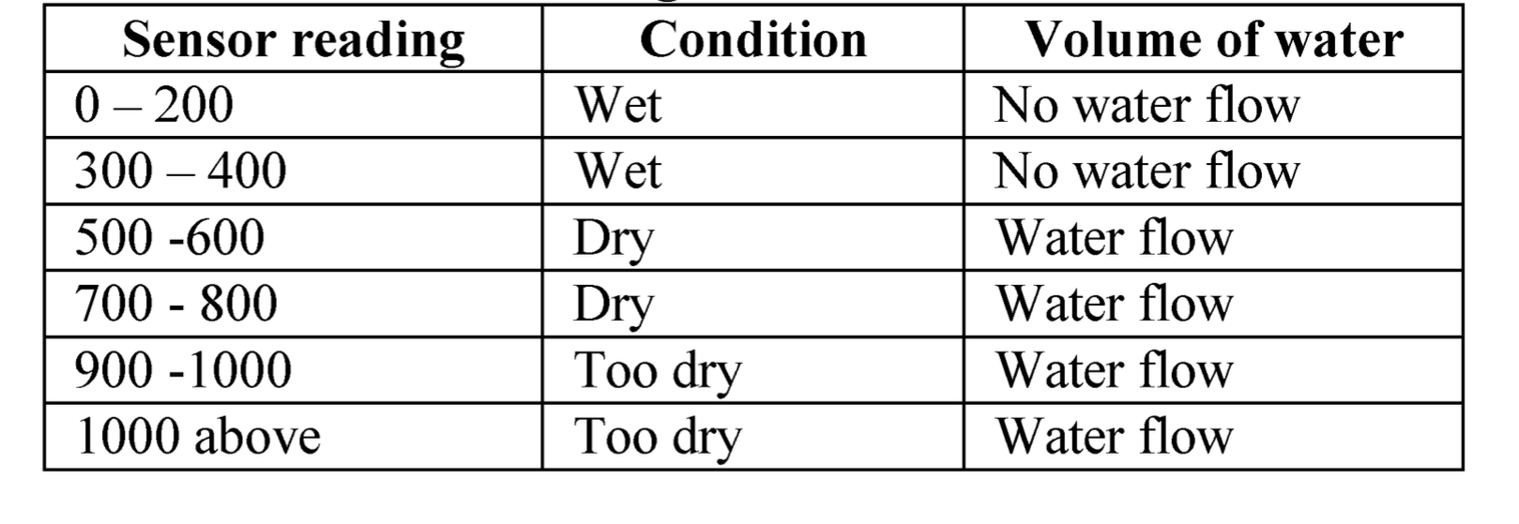
Table 1: Sensor Reading with The Volume of Water

4.2 GSM
Meanwhile, through this project, GSM module has been used as transceiver system that uses a network provider to connect and transfer data. GSM modem is a simple device which uses a SIM card to send and receive the messages to/from the user. The modem can be controlled by Arduino using serial communication. AT commands are used to configure the GSM modem [12].

GSM is proposed to be used in this prototype because it is will enable the user to activate the water system remotely, unlike using wireless system which enable only at certain specific range.

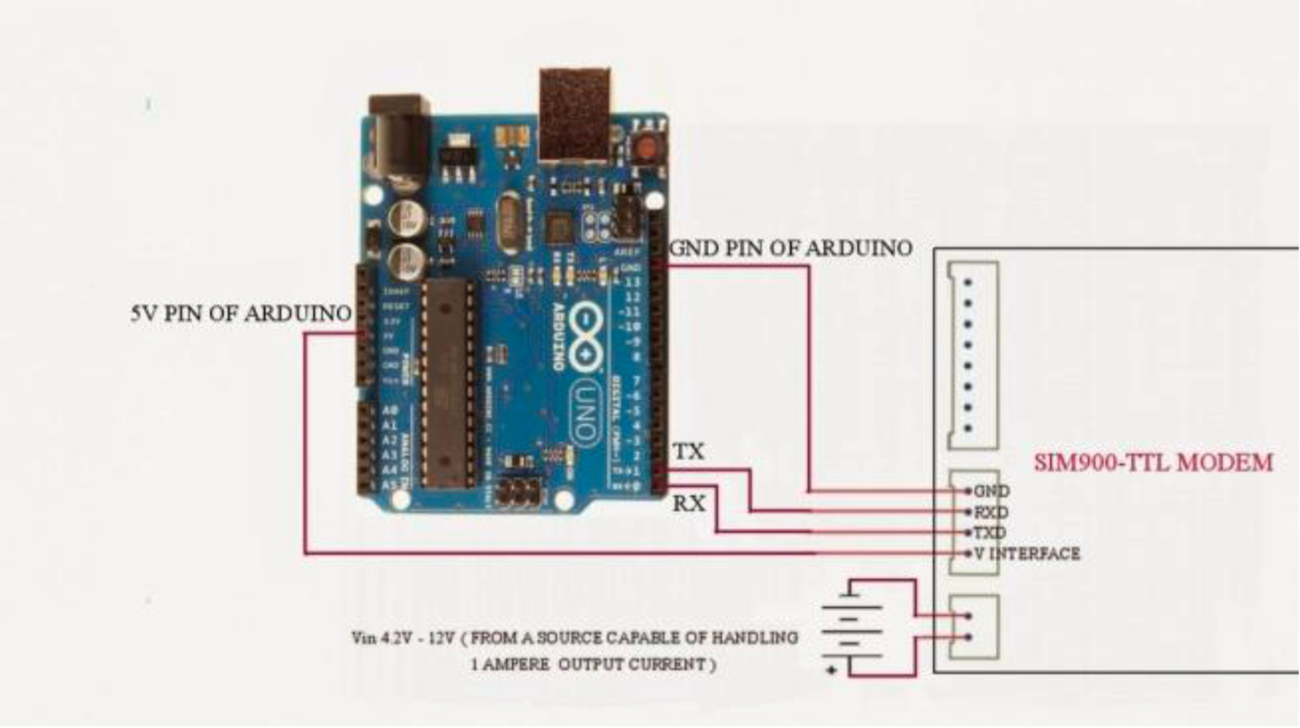
Figure 4.1: Connection of GSM With Arduino

4.3 Motor driver (L298N Dual H-Bridge)
Motor driver in this project is used to provide enough voltage for the pump.
4.4 Mini Water Pump
The water pump is used to channel water to the plants from the water tank. It is driven by the motor driver to the Arduino. The water pump will start working if the user has been informed that the soil is dry on his/her mobile phone via GSM module and the user send instruction to water the plant, vice versa.

CHAPTER 5
OPERATION DECRIPTION AND COMPLETE
CIRCUIT DIAGRAM

The operation of the watering system is described through the block diagram shown in Figure 4. Other parts needed in the design are Arduino Uno Board, Light Emitting Diode (LED), motor driver, water tank, water pump and moisture sensor. The motor driver is used in this project to provide enough voltage to the water pump.
The Arduino microcontroller is embedded with a program that will trigger the output with given input signals from the sensors. The power supply is regulated to 5 Volts. This is enough supply for the microcontroller to operate as a prototype. The sensor is placed into a various conditions of soil moisture which is normal, wet and dry soil. The connection of sensor consists of 3 wires which, one of the wires is connected to ground of the microcontroller, one is connected to vee of 5Volts of the microcontroller and another one is connected to analog pin in microcontroller board. The microcontroller is programmed using the reading of the sensor value. The process of this system is started with the RED LED is ON in which the water pump is OFF. Until the sensor value read more than 500, it will send a simple alert message to user that the soil is dry and needs to be watered. GSM will send the message to user and upon user reply ON and in the microcontroller programmed at position 1 is read as '1', the water pump will water the plants with the GREEN LED is ON. The water will stops until the sensor reached the reading of 500 (can be calibrated for different reading value) and RED LED will ON and GREEN LED is OFF.

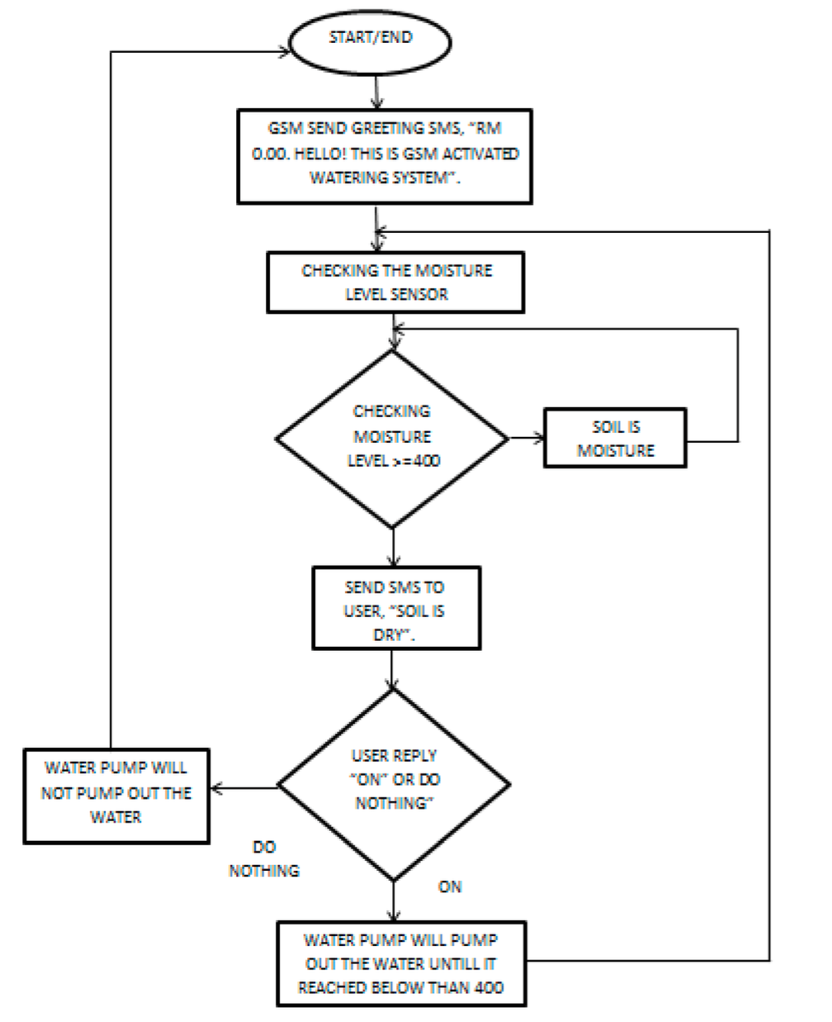

Figure 5.1: Operation Description

Table 2 below shown the operation description on the system based on the LED behavior.

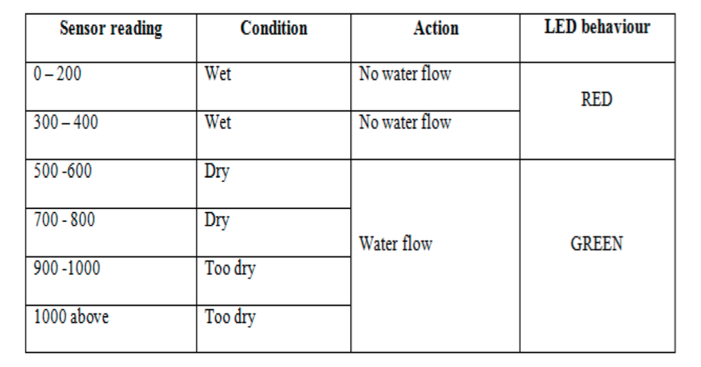
Table 2: Sensor Reading According to LED Behavior

Figure 5, below shows the complete circuit diagram of the watering system.

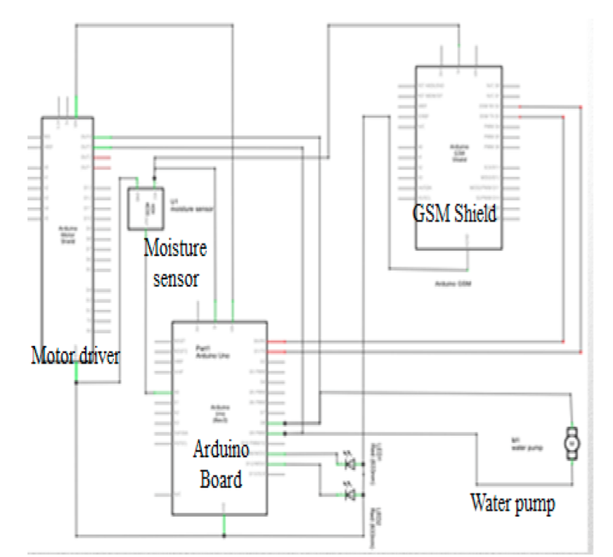
Figure 5.2: Complete Circuit Diagram

CHAPTER 6
RESULTS AND DISCUSSION
The Arduino UNO is connected directly with AC to DC adapter that is functioning as power supply for the system. The moisture sensor will start measuring according to the code that has been uploaded into the Arduino board. Then, if the analog sensor reading is reached more than 500 ( as coded), GSM will send a simple text SMS to user. User needs to reply "ON" or ignore the SMS and the system will not do anything. If user reply "ON" the water pump start working and the pump will stop until the moisture sensor reading reached 500.
Figure 6,7,8 below shows the picture related to the hardware of the system.
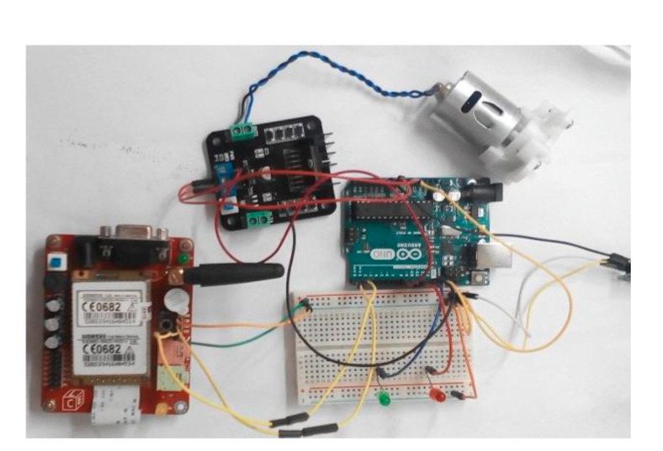
Figure 6: Connection Circuit of The Control Unit

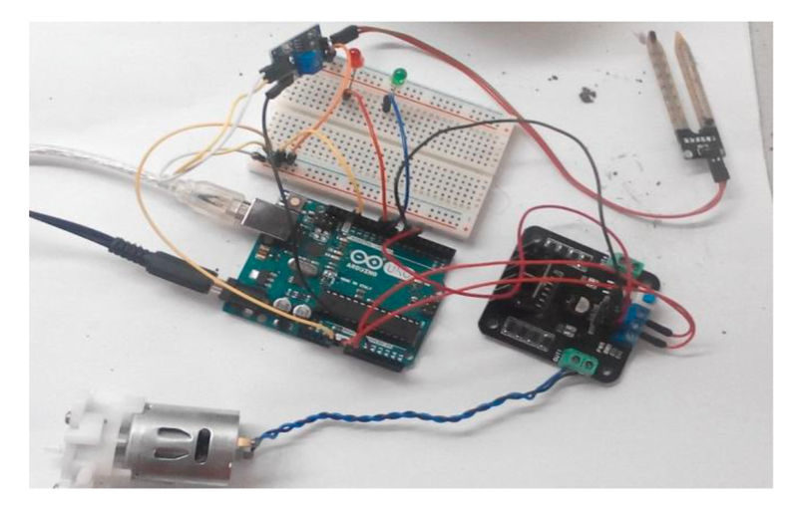
Figure 7. Overall View of the System

The data from the moisture sensor monitoring hardware were successfully transmitted using GSM sim900 and Arduino Uno board. A prototype has been successfully developed, implementing a watering system that reduces time and energy of the user in maintaining their farm. It is quite efficient; for it has wide area coverage since it uses the cellular network. Figure 8 shows that the simple message received by the user if the sensor triggers valued that more than 500.

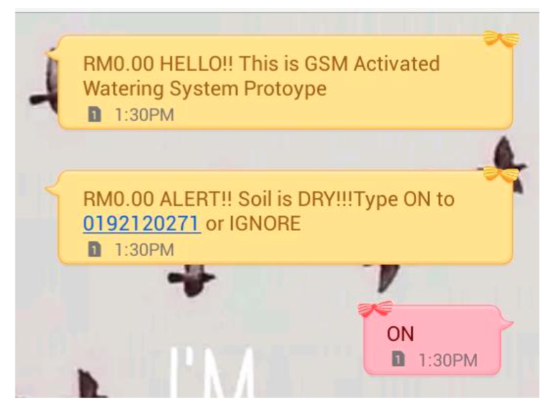
Figure 8: SMS Received by The User

The SMS that has been send to alert the user that the soil needs to be watered. The user needs to reply 'ON' to start the water pump to pump out the water to water the plant.

CONCLUSION
Soil moisture is a crucial variable in the environment and climate systems. It has great impacts on agricultural and hydrological processes, and acts as a key role in agricultural. Besides, specific plants need specific amount of water for growth, reproduction and photosynthesis. Thus, this system has been built to increase the efficiency for maintaining the garden especially for urban people. The moisture sensor system will alert the user by sending 'Short Message Services' when the soil is dry. It is functioning as a protection for the plants in the garden from wilting. A Thorough characterization of soil moisture content for different plants could be done for future works as extension of this prototype.
Furthermore, due to the advanced in technologies, the extension of this prototype will be more towards the "Internet of Things", with the application using android as triggered ON for the system.

ACKNOWLEDGEMENT
Firstly, the authors would like to express her gratitude to her supervisor Dr. Aziati Husna binti Hj Awang for spending her time and give useful ideas to help the author to complete her project. Besides that, the authors would like to thank the Faculty and staff for prepare the needs for the project to succeeds. For overall, the authors would like to thank to those who participated to complete this final year project.

REFERENCES
[1] Keith Bellingham, The Role of Soil Moisture on our Climate, Weather and Global Warming, [online], A vailable FTP; http://www.stevenswater.com/articles/soilandclimate.aspx
[2] Sheila Johnson, The Impact of Global warming on Soil gardening system using low-cost soil moisture sensor", [nternational Conference on Technologies for sustainable development(lCTSD-20[5), Feb.04-06,2015,
[3] Garden village, http://www.gardenweb.com/sesbania/watering.html
[4] Aravind Anil Aravind R Thampi , Prathap John M and Shanthi K J, "Project HARITHA - An Automated Irrigation System for Home Gardens", [EEE, Kerala [ndia, 2012.
[5] A.K.Tripathy, A.Vichare,R.R.Pereira, V.D.Pereira, J.A.Rodrigues, 'Open Source Hardware based automated
[6] Peng Yue, Senior Member, IEEE, Liangcun Jiang, and Lei Hu, Google Fusion Tables for Managing Soil Moisture Sensor Observation, IEEE journal of Selected Topic in Applied Earth Observations and Remote Sensing, Vo1.7, No.ll, November 20[4.
[7] Mahir Dursun, Semih Ozden, A wireless application of drip irrigation automation supported by soil moisture sensors, Scientific Research and Essays Vol. 6(7), pp. 1573-1582,4 April, 201l.
Moisture, [online], http://science.opposingviews.com/
A vailable FTP;
[8] Ye Na, Liu jun feng,"Smart Orchard Soil Moisture Monitoring System Based on Wireless Communication Technology", 978-1-4244-6055-71101$26.00,2010, IEEE
[9] Azzouz Benzekri, Kamal Meghriche, Larbi Refoufi, PC-Based Automation of a Multi-Mode Control for an Irrigation System, [ndustrial Embedded Systems, 2007 International Symposium on, 2007.
[10] Y uya Suzuki, Hirofumi [bayshi, Hiroshi Minero,"An SVM Based Irrigation Control System for home gardening", 2013, IEEE 2nd Global Conference on Comsumer Electronics (GCCE), 978-1-4799-0892- 9113/$3l.00,20l3 IEEE

[11] Aravind Anil Aravind R Thampi , Prathap John M and Shanthi K J, "Project HAR[THA - An Automated Irrigation System for Home Gardens", IEEE, Kerala India, 20 [2.
[12] Jay Nagdeo, Priya Mehta, Remotely Controlled Automated Irrigation System, international journal of engineering research and development, Vol 10, Issue
11, November 2014.

